ProjectPlanningPhase

**ProjectPlanningTemplate(ProductBacklog,SprintPlanning,Stories,Storypoints)**

|  |  |
| --- | --- |
| Date | 21September2023 |
| TeamID | NM2023TMID05015 |
| ProjectName | GlobeTrekInsights:NavigatingGlobal  CountryDataWithIBMCognos |
| MaximumMarks | 8Marks |

# ProductBacklog,SprintSchedule,andEstimation(4Marks)

Usethebelowtemplatetocreateproductbacklogandsprintschedule

|  |  |  |  |  |
| --- | --- | --- | --- | --- |
| **Sno** | **Title** | **MemberNames** | **Description** | **Date** |
| **1** | **Sprint1** | **Arnikak** | **DataCollectionandIngestion** | **Sep17-Sep20,**  **2023** |
| **2** | **Sprint2** | **Anusornak,Arnikak** | **DataProcessingandAnalysis** | **Sep21-Sep25,**  **2023** |
| **3** | **Sprint3** | **Anusornak** | **UserInterfaceDesignandVisualization** | **Sep26-Sep29,**  **2023** |
| **4** | **Sprint4** | **Aravinths,,Arunkumarg** | **Data Integration andFrameworkModeling** | **Oct1-Oct6,2023** |
| **5** | **Sprint**  **5** | **Aravinths** | **UserAuthenticationandSecurity** | **Oct8-Oct14,2023** |
|  |  |  |  |  |
| **6** | **Sprint6** | **Arnikak** | **Reporting andDashboardDevelopment** | **Oct15-Oct18,2023** |
| **7** | **Sprint**  **7** | **Arunkumar**  **g,Anusornak** | **TestingandQualityAssurance** | **Oct19-Oct20,2023** |
| **8** | **Sprint8** | **Arnikak,Aravinths** | **DeploymentandRelease** | **Oct21-Oct22,2023** |

|  |  |  |  |  |  |  |
| --- | --- | --- | --- | --- | --- | --- |
| **Sprint** | **FunctionalRequirement**  **(Epic)** | **Numb**  **er** | **UserStory/Task** | **StoryPoints** | **Priority** | **Team** |
| **Sprint1** | **DataCollection** | **US001** | **AsaMarketingManager,IwanttoaccessIBMCognosAnalyticstocollectdataforcampaignanalysis.** |  | **High** | **Arnika kAnusorna kAravinds**  **Arunkumar g** |
|  | **DataIntegration** | **US002** | **AsaDataAnalyst,Iwanttointegratedatafromvar**  **ioussourcesintoIBMDb2.** |  | **High** | **Anusorna**  **k,Arnikak** |
|  | **DataSecurity** | **US003** | **AsanITSpecialist,Iwanttoensuresecuredataaccessandencryptionduringinteg**  **ration.** |  | **High** | **Aravinth sArunkumarg** |
| **Sprint2** | **Data** | **US004** | **AsaDataAnalyst,Iwanttocleanandtransformdataforaccurateanalysis.** |  | **High** | **Arnikak** |
|  | **DataAnalysis** | **US005** | **AsaDataAnalyst,IwanttouseIBMCognosAnalyticstoanalyzemarketingcampaign**  **data.** |  | **High** | **Anusornak** |
|  | **DataVisualization** | **US006** | **AsaDataAnalyst,Iwanttocreatedata**  **visualizationstorepresentcampaigninsights.** |  | **High** | **Arunkumar**  **g,AraviAravinths** |
| **Sprint3** | **DataPresentation** | **US007** | **As a Marketing Manager, I want toviewdashboardswithcampaigninsightsandtrends.** |  | **High** | **Anusornak** |
|  | **Decision-Making** | **US008** | **AsaMarketingManager,Iwanttomakedata-**  **informeddecisionsforcampaignoptimization.** |  | **High** | **Arunkumargl** |
|  | **Compliance**  **andPrivacy** | **US009** | **AsaComplianceOfficer,IwanttoensureGDPRc**  **omplianceindatahandling.** |  | **High** | **aravinths** |
| **Sprint4** | **BudgetOptimization** | **US010** | **As aFinanceTeam member,Iwanttousedatainsightstooptimizecampaignbudgets.** |  | **Medium** | **Arnikak** |
|  | **CustomerFeedbackAnalysis** | **US011** | **AsaCustomerSupportrepresentative,Iwanttoanalyzecustomerfeedbackdata.** |  | **Medium** | **Aravinths** |
|  | **Real-TimeInsights** | **US012** | **AsaMarketingManager,Iwanttoaccessreal-timemarketingcampaigninsights.** |  | **Medium** | **Arunkumarg** |
| **Sprint5** | **CollaborationToolsIntegration** | **US013** | **Asa ProjectManager,Iwanttointegratecollaborationtoolsforteamcommunication.** |  | **Medium** | **Anusornak** |
|  | **MobileCompatibility** | **US014** | **AsaUser,Iwanttheapplicationtobeaccessibleonmobiledevicesfor**  **convenience.** |  | **Medium** | **Arnikak** |
|  | **DataBackupandRecovery** | **US015** | **AsanIT Specialist,Iwanttoimplementdatabackupandrecoverysolutions.** |  | **Medium** | **Aravinths,Arunkumarg** |
| **Sprint6** | **UserTraining** | **US016** | **AsaProjectManager,Iwanttoconductusertraining**  **andprovideresources.** |  | **Low** | **Anusornak** |



|  |  |  |  |  |  |  |
| --- | --- | --- | --- | --- | --- | --- |
|  | **O**  **ptimization** | **US017** | **As an IT Specialist, I want tooptimizeapplicationperformanceforfasterdata**  **analysis.** |  | **Low** | **aravinds** |



|  |  |  |  |  |  |  |
| --- | --- | --- | --- | --- | --- | --- |
|  | **Integration**  **withMarketingTools** | **US018** | **AsaMarketingManager,Iwanttointegratethe**  **applicationwithmarketingautomationtools.** |  | **Low** | **Anusornak** |
| **Sprint7** | **FinalTesting** | **US019** | **AsaQASpecialist,Iwantto**  **conductcomprehensivetestingbeforedeployment.** |  | **High** | **Arumkumarg** |
|  | **Planning** | **US020** | **AsaProjectManager,Iwanta**  **detaileddeploymentplanforaseamlessrollout.** | 5 | medium | arnikkak |
| **Sprint8** | **Revie**  **w** | **US021** | **Asa ProjectManager,Iwanttoreviewthedeployment'ssuccessandgatherfeedback.** |  | **High** | **Anusornak** |
|  | **Documentation** | **US022** | **AsaTechnicalWriter,Iwanttocreatesystemdocumentationforreference.** |  | **High** | **Arunkumar garavintAravint**  **hs** |
|  | **ProjectClosure** | **US023** | **AsaProjectManager,Iwanttoclosetheprojectandconductafinalassessment.** |  | **High** | **Arnika k ,AnusAnusornak,AraviAravinths,ArunkuArunkumarg** |



# Velocity:

Imaginewehavea10-daysprintduration,andthevelocityoftheteamis20(pointspersprint).Let’ scalculatetheteam’ saveragevelocity(AV)periterationunit(storypointsperday)



# BurndownChart:

Aburndownchartisagraphicalrepresentationofworklefttodoversustime.ItisoftenusedinagilesoftwaredevelopmentmethodologiessuchasScrum.However,burndownchartscanbeappliedtoanyprojectcontainingmeasurableprogressovertime.

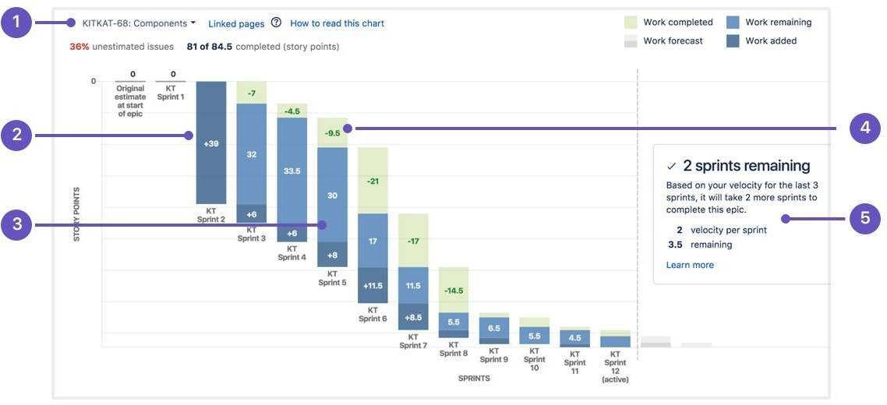

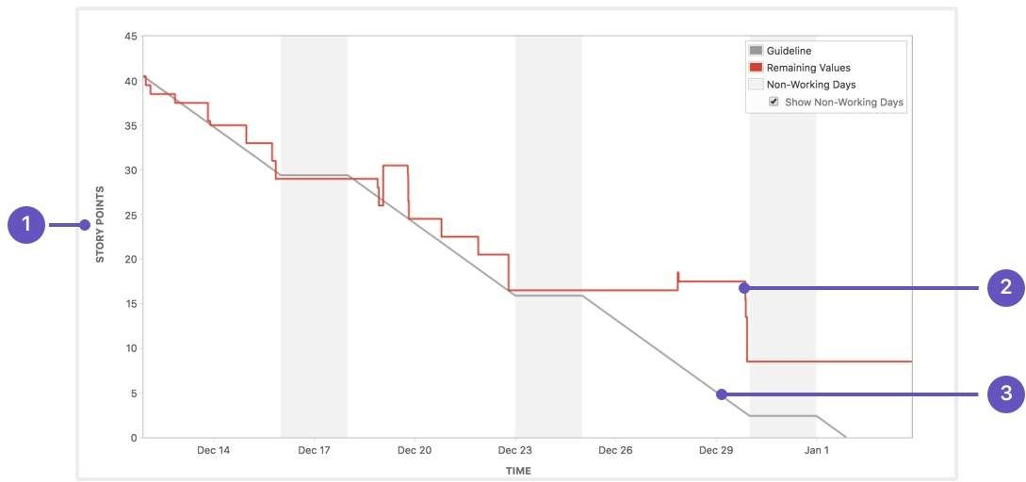

**SEP14**

**SEP30**

**OCT**

**OCT**

**OCT**

**OCT**

**SEP**